
CADET COLLEGE FATEH JANG

ATTACH THREE
PASSPORT SIZE
PHOTOGRAPH
FOR OFFICIAL USE ONLY
Since 2001
CLASS________ REGISTRATION NO: __________ PC NO: __________
STATUS - ADMISSION GRANTED / NOT GRANTED
READ ALL INSTRUCTIONS CAREFULLY BEFORE FILLING APPLICATION FORM. CAREFULLY READ FORM BEFORE FINAL SUBMISSION ALSO READ THE COLLEGE RULES AND REGULATIONS MENTIONED IN THE WEBSITE HTTPS://WWW.CCF.EDU.PK
- APPLICATION FORM VALID FOR ADMISSION IN CLASS 6TH, 7TH, 8TH& 9TH FOR SESSION 2026 ONLY.
- FILL THIS FORM IN CAPITAL LETTERS ONLY.GIVE VALID POSTAL ADDRESS AND MOBILE NUMBERS.
- ATTACH THREE RECENT PASSPORT SIZE PHOTO & A COPY OF NADRA FORM B& FATHER CNIC COPY.
- PAY ENTRY TEST BANK CHALLAN FEE OF RS 4100/- PKR IN ANY MCB BANK COUNTRY-WIDE BRANCH
- ATTACH PAID BANK CHALLAN COPY. FORM WITHOUT PAID BANK CHALLAN WILL NOT BE ACCEPTED.
APPLYING FOR ADMISSION IN CLASS: ______
ADMISSION PREFERENCE
REGULAR APPLICANT (OPEN MERIT) SELF FINANCE
Extra Fee:

- Admission on a self-financed basis does not guarantee a seat in the college; however, it may increase chances of admission.
- Selection will be based on merit and the availability of slots only.
- The merit for self-finance applicants may be lower, but they are required to pay an additional admission fee at the time of admission.

CANDIDATE PARTICULAR (FILL IN CAPITAL LETTERS ONLY)

1. NAME OF THE CANDIDATE ______________________________________________________________________________

2. DATE OF BIRTH ____________ (DD/MM/YY) MOTHER TONGUE ________________, PLACE OF BIRTH _________________

3. AGE AS ON 1STMARCH 2027: _____YEAR ____MONTH, NADRA B-FORM No: _________-___________________-______

4. RELIGION ____________________ SECT. _______________ WEIGHT ___________________HEIGHT ________________

FATHER’S / GUARDIANS PARTICULAR

5. RELATION WITH APPLICANT: _______________________, FULL NAME____________________________________________

6. PRESENT POSTAL / MAILING ADDRESS _____________________________________________________________________

_________________________________________________________________________________________________________

7. PERMANENT ADDRESS (AS PER CNIC NADRA ID CARD) ________________________________________________________

_____________________________________________________________________________________________________

-

-

8. FATHER/ GUARDIANCNIC NADRA ID CARD NO:

9. MOBILE NO’S: ____________________________________ WHATSAPP NUMBER_________________________________

10. LANDLINE WITH AREA CODE: ___________________________ OFFICE LANDLINE ________________________________

11. OCCUPATION ______________________________ MONTHLY INCOME IN PKR/- _________________________________

12. EMAIL: __________________________________________ NATIONALITY: _______________________________________

IN CASE OF EMERGENCY

13. FULL NAME: ______________________________________, RELATION WITH APPLICANT: __________________________

-

-

14. FATHER CNIC ID CARD NO.

15. PRESENT ADDRESS ____________________________________________________________________________________

____________________________________________________________________________________________________

16. MOBILE NO. ___________________________________ LANDLINE WITH AREA CODE: _____________________________

EDUCATION DETAILS

17. NAME OF SCHOOL ____________________________________________________________________________________

18. CLASS STUDYING IN: _____________________________ APPLYING IN CLASS: ________________________________

ENTRY TEST CENTER

College Campus /
ISB / RWP

19. SELECTED EXAMINATION
Multan
Karachi
CENTER

FEE DETAIL

MCB BANK BRANCH: _____________________ BRANCH CODE: __________________________

AMOUNT DEPOSITED:_______________________ DATE OF FEE DEPOSIT _______________________

(NOTE: ATTACH PAID BANK CHALLAN COLLEGE COPY ALONG WITH OTHER DOCUMENTS WITH APPLICATION FORM)

DOCUMENTS CHECK
PHOTCOPY OF CNIC ID CARD FATHER & MOTHER / GUARDIAN (MANDATORY)

THREE PASSPORT SIZE PICTURE (MANDATORY)

PHOTOCOPY OF NADRA FORM “B”

PAID BANK CHALLAN COLLEGE COPY (MANDATORY)

UNDERTAKING
I ________________________________ Father / Guardian of _____________________________________ do hereby solemnly undertake and affirm that I have read and understood the rules and regulations as given in the prospectus / website.
I do undertake to abide by the rules and regulations and also with the changes incorporated / amended from time to time.
I shall abide by the College Rules and accept Principal’s decision in all academic and disciplinary matters concerning my child.
I also affirm that all information provided by me in this form is correct and according to the best of my knowledge and belief.

Date: _________________________ _______________________________________
Signature of the Father / Guardian
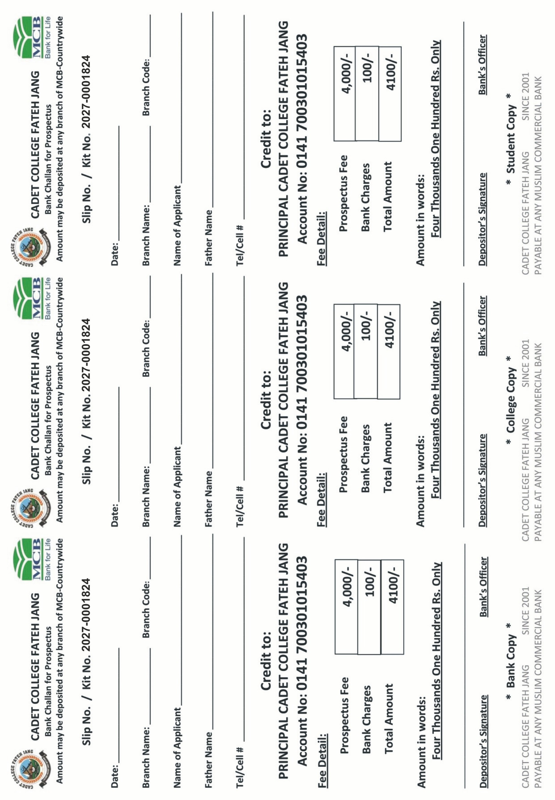
PAGE 2 OF 3 (BEFOR PRINTING SCALE PAGE SIZE TO A4) APPLY SESSION 2027-2028 BANK CHALLAN INCLUDED WWW.CCF.EDU.PK

